**About AmplEnviron**

AmplEnviron Pvt. Ltd. (AEPL) believes in sharing our knowledge and working in partnership with our customers, clients to develop sustainable, innovative and cost effective solutions. Environment essentially being a multi-disciplinary science, the range of services offered by us are also comprehensive and cater to the varied needs of industries. AEPL is having a Team of Well Experienced, Knowledgeable, dedicated team of expert professionals committed to reduce industrial pollution control and promote sustainable development.

Mission, Vision & Values

**Mission**

To deliver sustainable environmental solutions to our clients through quality consultancy services and ensure their commitment towards environmental protection.

**Vision**

By 2024, we will be the clear leader in the field of Environment to support sustainable Development, we will double in value and we will deliver on our promises to our clients and our people.

**Values**

|  |  |  |  |
| --- | --- | --- | --- |
| **ACCOUNTABILITY**  Responsible for the success of AEPL and for the delivery of quality work to our clients | **DRIVE AND PASSION**  Believe in a CAN DO attitude, coupled with action that believes in making a difference | **FOCUS**  Committed to sustainability and to act in an environmentally friendly way | **MUTUAL RESPECT**  We believe in mutual respect |
| **INNOVATION** Encourage and provide favorable environment for innovative approach to solutions | **INTEGRITY**  We committed to transparent and highest level of ethical behavior | **QUALITY**  We always strive for excellence in the services we provide and in the results we produce | **TEAM WORK**  We value work together to succeed |

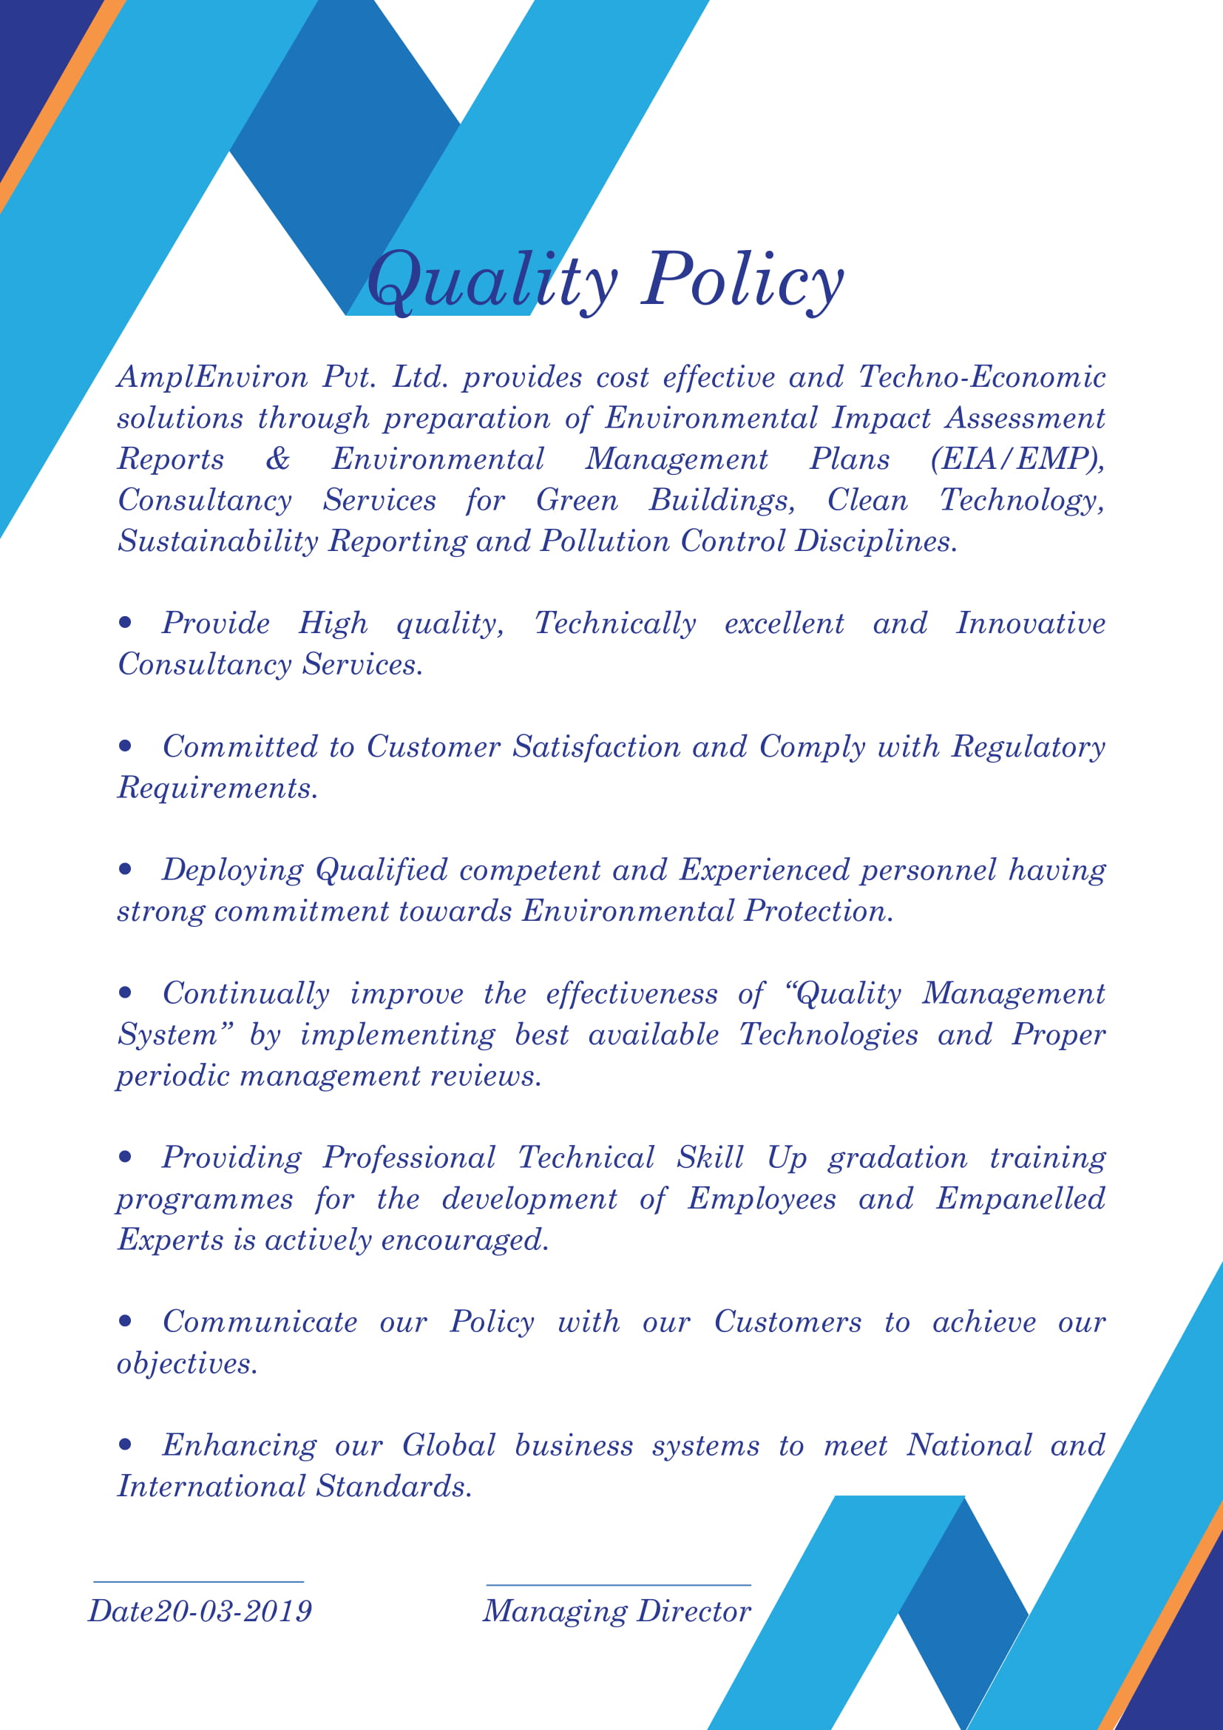

**Services**

**Consultancy services**

* Facilitate Environmental Clearances for all industrial developmental projects
* Preparation of Environmental Impact Assessment Reports
* Facilitating Consent for Establishment and Consent for Operate to all industrial developmental projects.
* Single window Industrial License Clearances
* Facilitating Costal Regulatory Zone Clearances and Forest Clearances
* Project Feasibility Reports (PFR) & Detailed Project Reports (DPR)
* Sustainability reporting as per GRI standards
* Environmental site due diligence studies, clean up strategies and remediation plans
* Environmental Compliance Monitoring
* Socio Economic Assessment / Demographic Surveys
* Ecology & Biodiversity Studies
* Rehabilitation and Resettlement studies
* Traffic density surveys
* Corporate Social Responsibility
* Environmental Modeling
* Land use/ Land cover analysis using with RS and GIS
* Risk Assessments (MCA, HAZON, HAZOP) and Disaster Management Plans
* Hydrogeological studies and Ground water mapping
* Energy Efficiency Building Code (ECBC)
* Extended Producer Responsibility Certification (EPR) - for E – Waste management or Plastic waste
* ISO Certifications
* Environmental Training

**Engineering Services**

* Design, Supply, Commissioning and Maintenance of

[Effluent Treatment Plants](http://kadamenviro.com/effluent-treatment-plants.aspx)

[Common Effluent Treatment Plants](http://kadamenviro.com/effluent-treatment-plants.aspx)

[Water Treatment Plants](http://kadamenviro.com/effluent-treatment-plants.aspx)

[Sewage Treatment Plants](http://kadamenviro.com/sewage-treatment-plants-services.aspx)

* [Rainwater Harvesting](http://kadamenviro.com/rainwater-harvesting-services.aspx)
* [Biogas Plants](http://kadamenviro.com/biogas-plants-services.aspx)
* Solid Waste Management System

**AmplEnviro-Legal Services**

* Dealing with legal issues related to environment
* Non-compliance issues, NGT cases, NOC & EC violation cases

**Sectors we serve**

**Please refer to** [**http://www.voyants.in/sectors/**](http://www.voyants.in/sectors/) **site for sectors page original pics are in the same folder.**

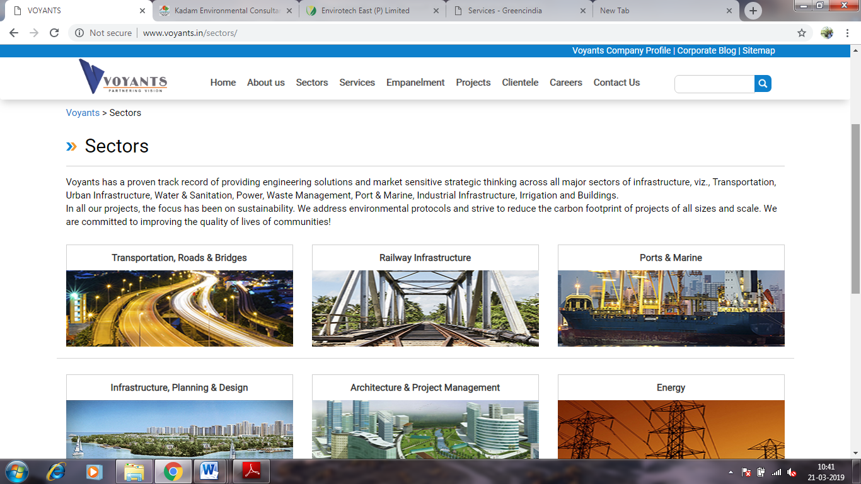

List of sectors page

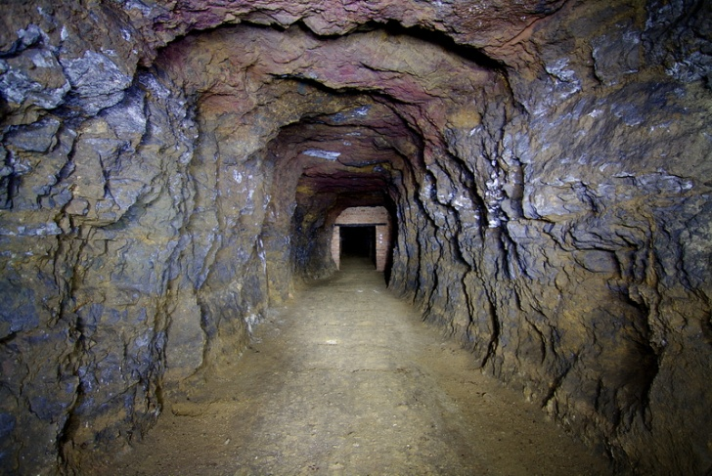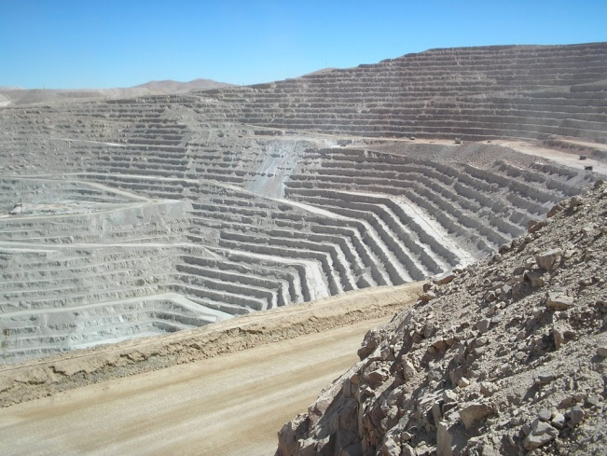

Mining of minerals including opencast / underground mining



Offshore and Onshore Oil and Gas exploration, development & production

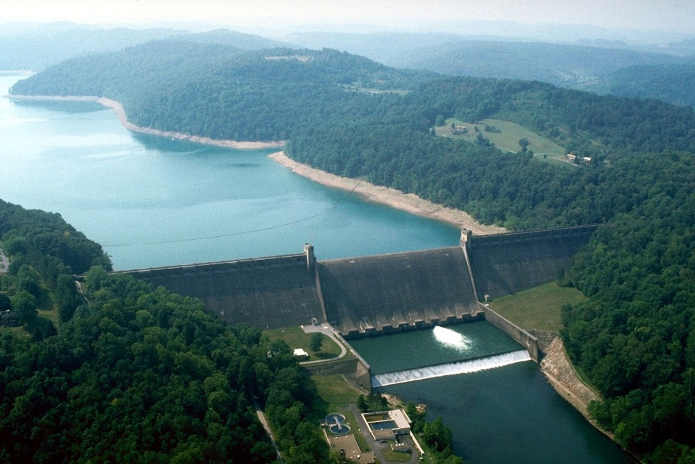

River Valley projects

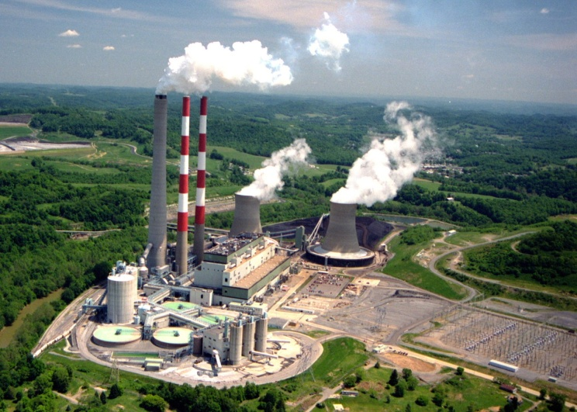

Thermal power plants

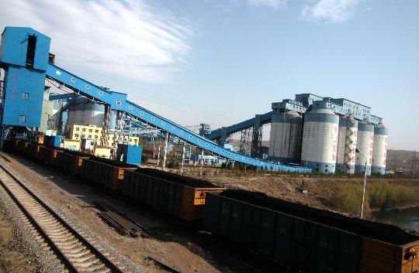

Coal Washeries

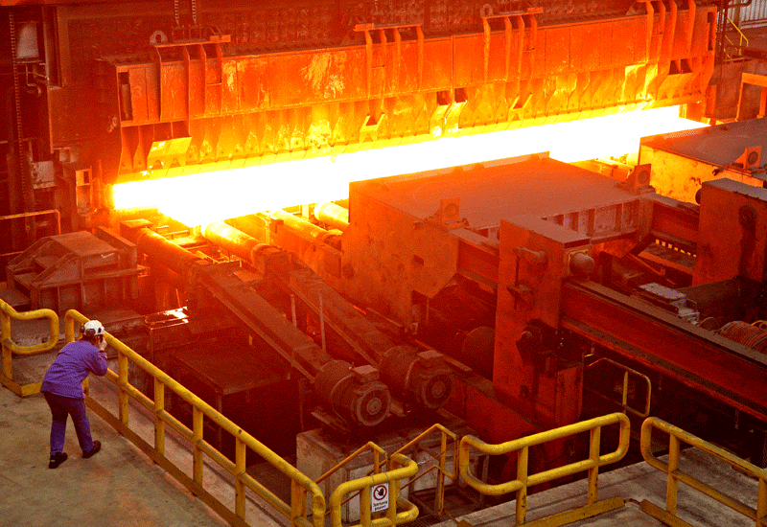

Metallurgical industries (ferrous & non-ferrous)

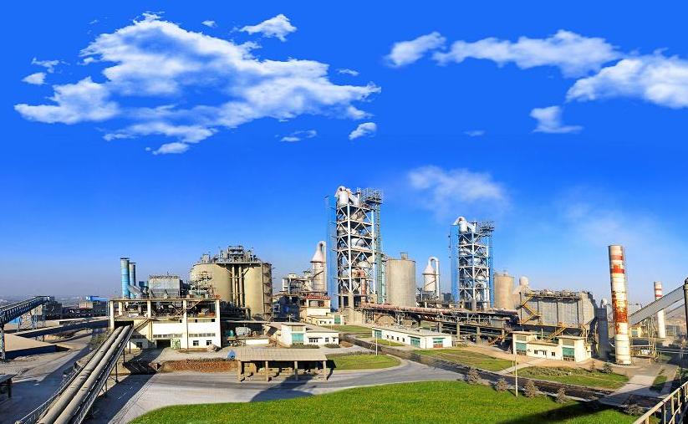

Cement Plants

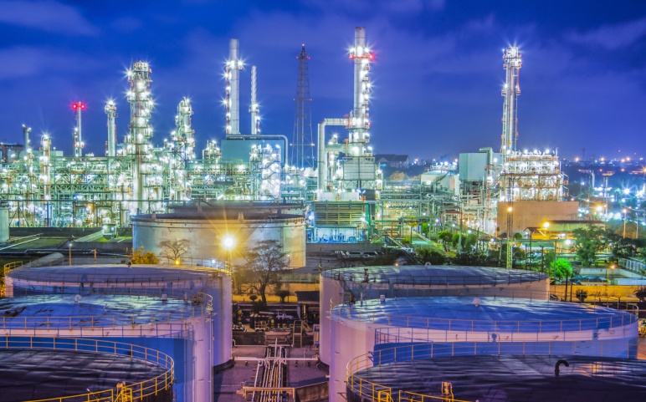

Petroleum Refining

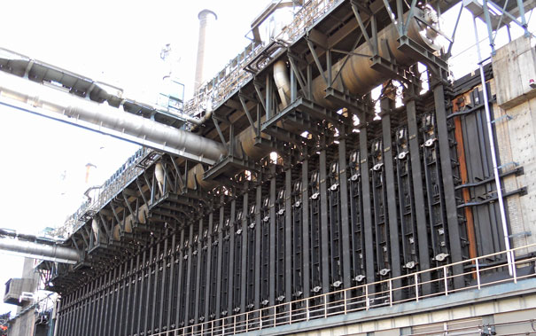

Coke oven plant

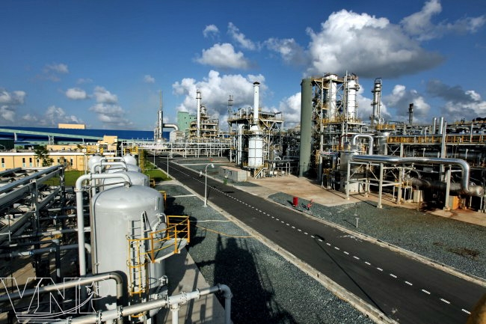

Chemical fertilizers, Pesticides industry

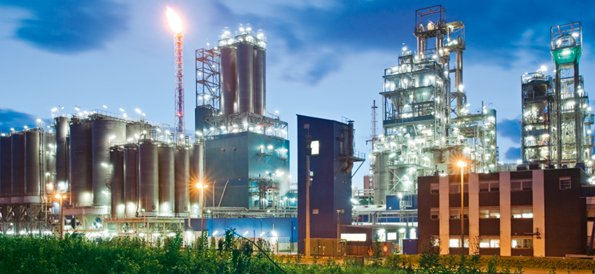

Petro-chemical complexes



Synthetic organic chemicals industry

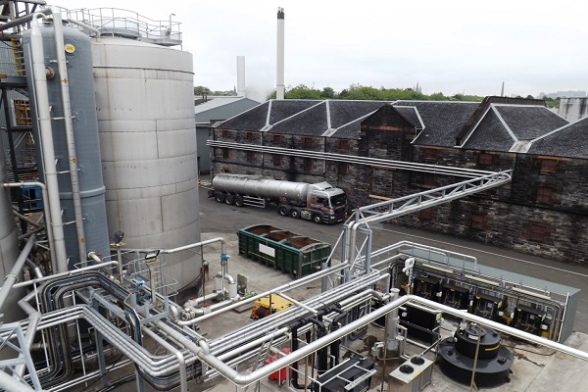

Integrated paint industry

Distilleries





Pulp & paper industry

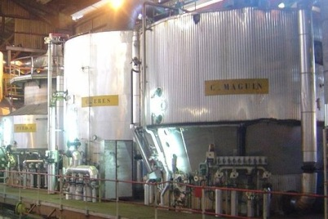

Sugar Industry

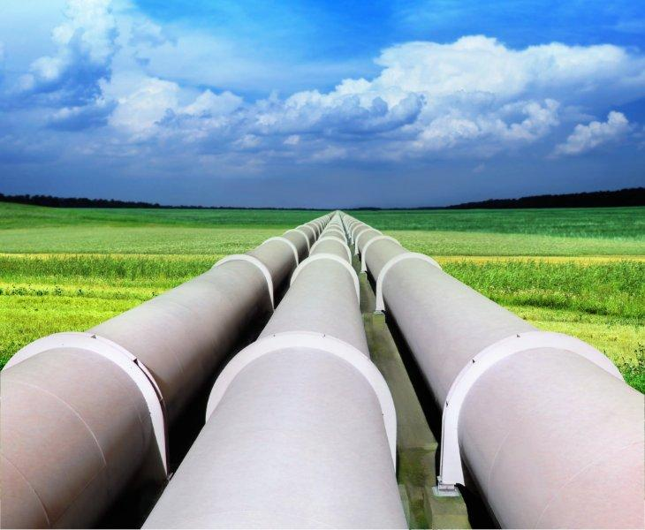

Oil & gas transportation pipeline

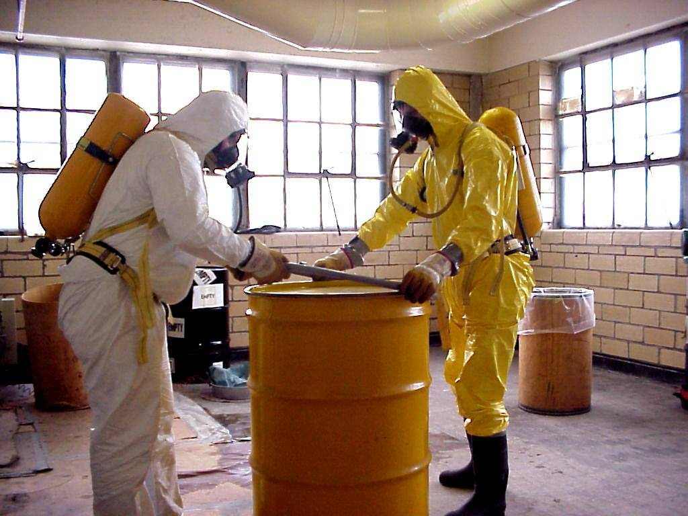

Isolated storage & handling of Hazardous chemicals



Air Port

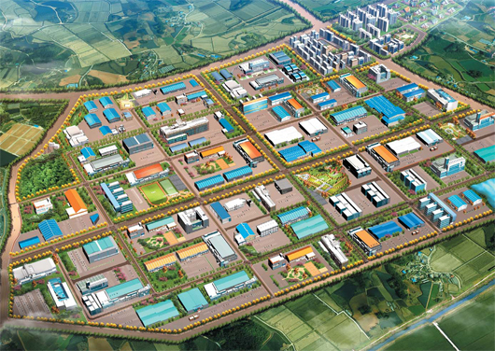

Industrial estates/ parks/ complexes/areas, EPZs, SEZs Biotech Parks

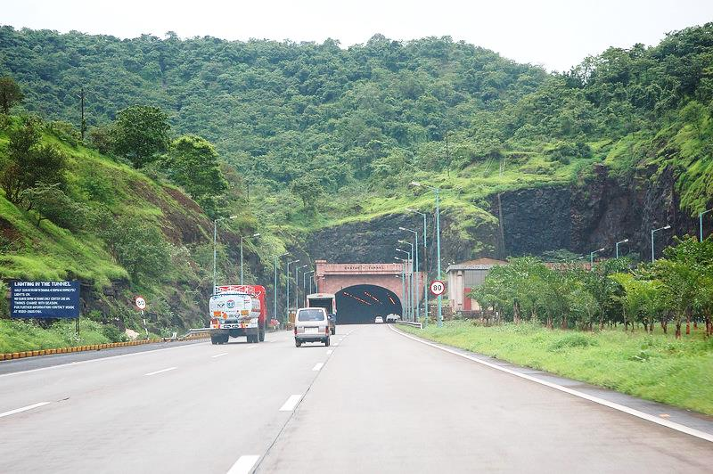

Highways

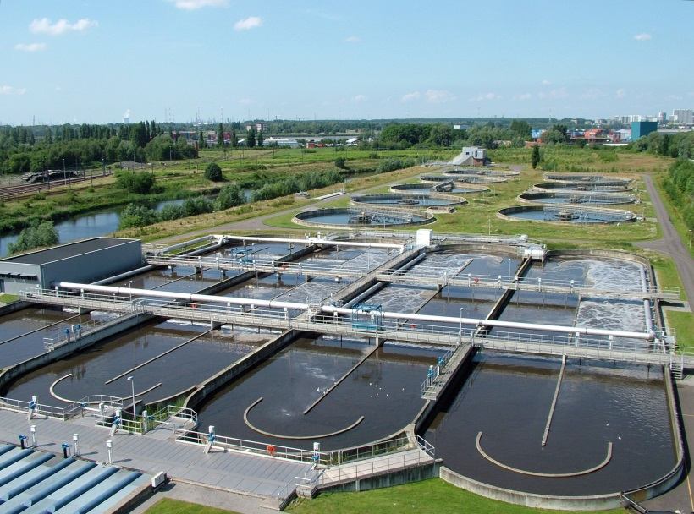

Common Effluent Treatment Plants (CETPs)

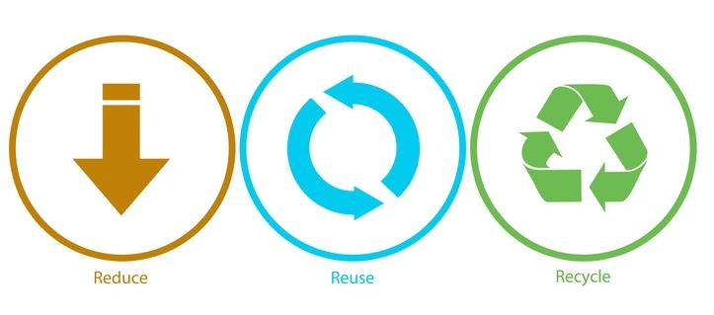

Common Municipal Solid Waste Management Facility (CMSWMF)

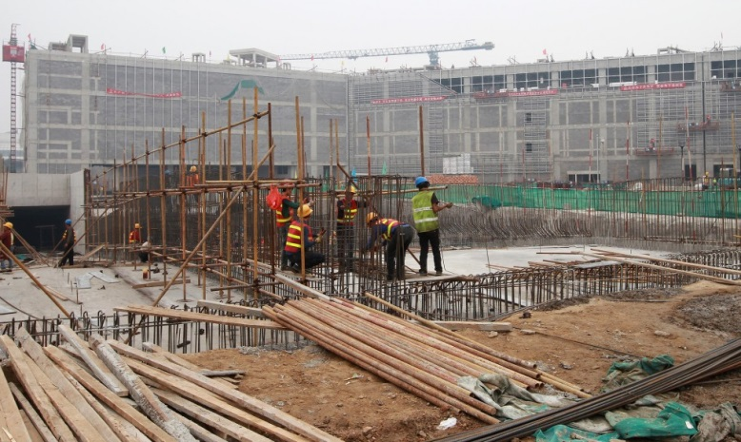

Building and construction

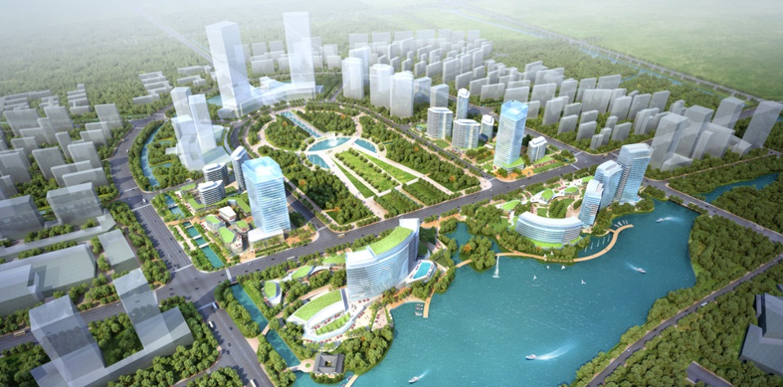

Townships and Area development projects

**Enquiry**

**Please refer** [**https://www.vimta.com/**](https://www.vimta.com/) **site**

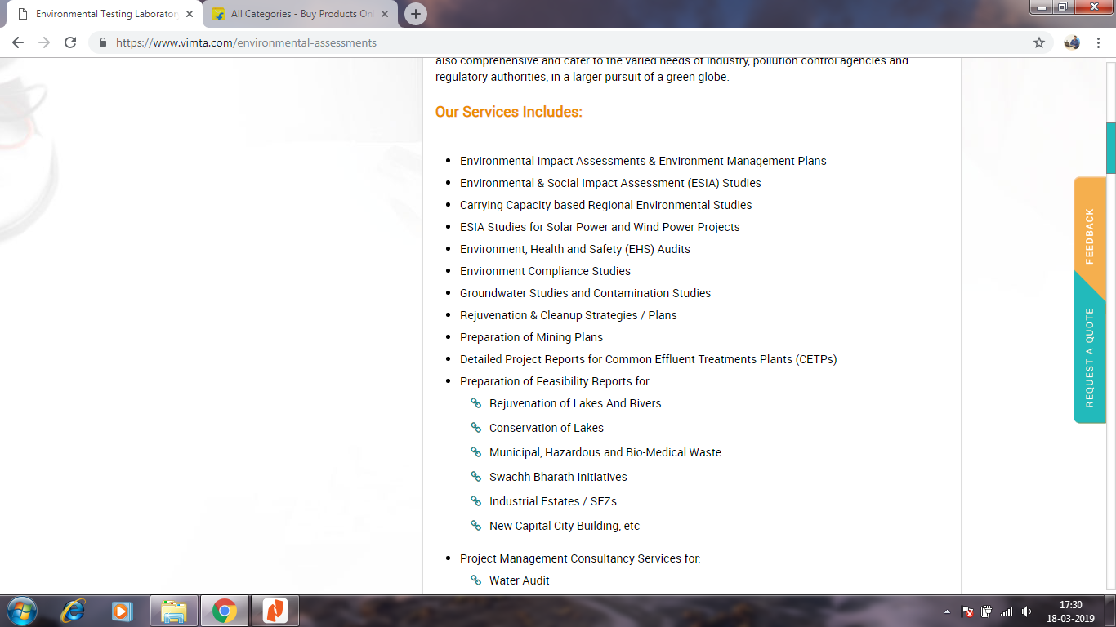

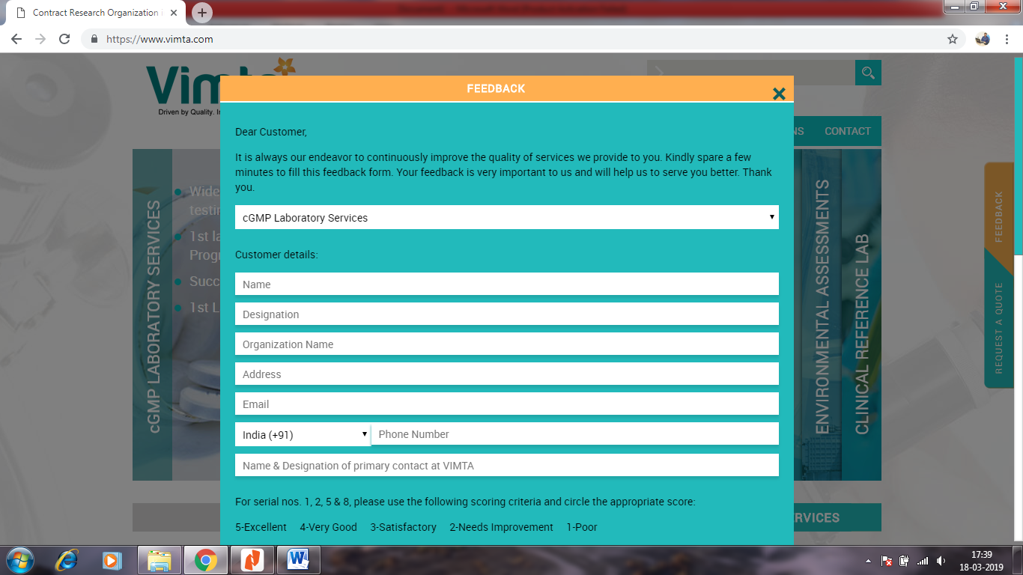

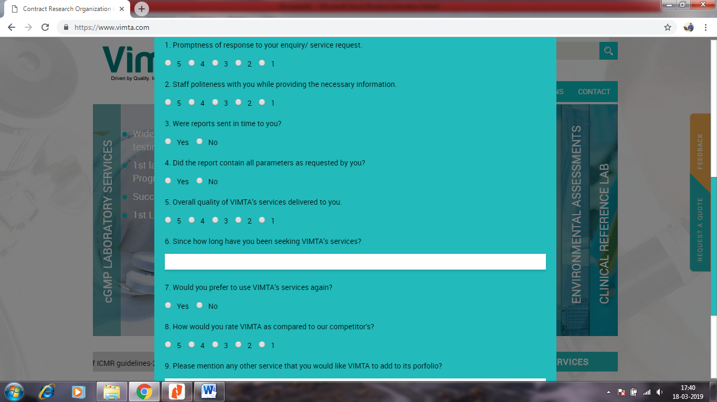

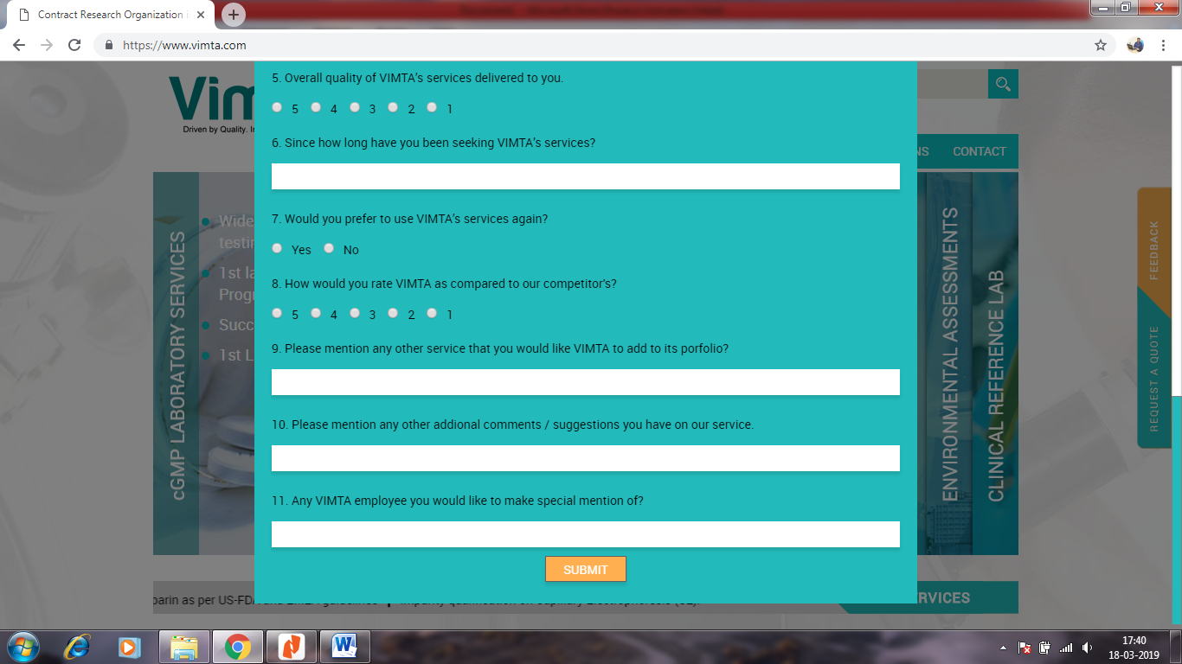

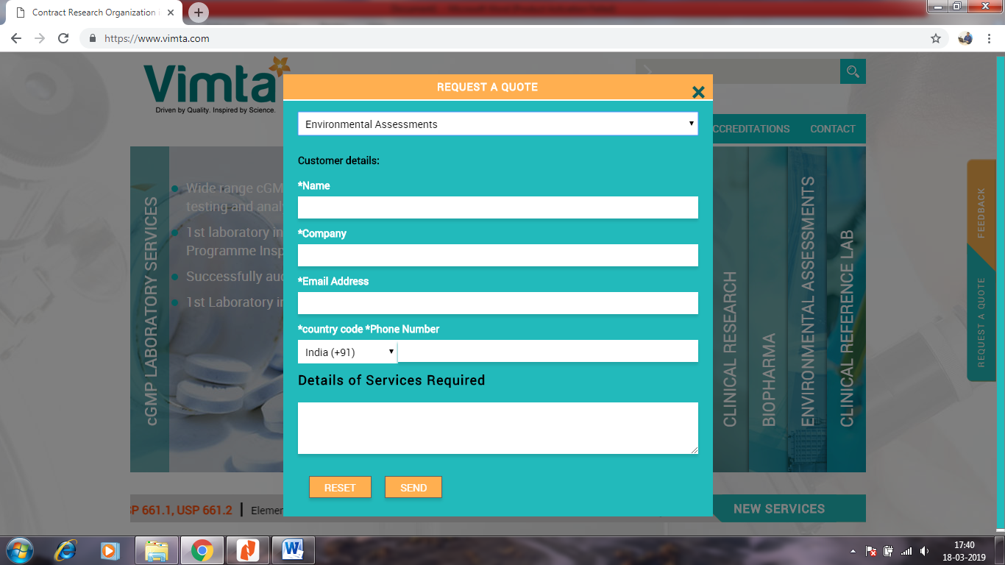

For Logo

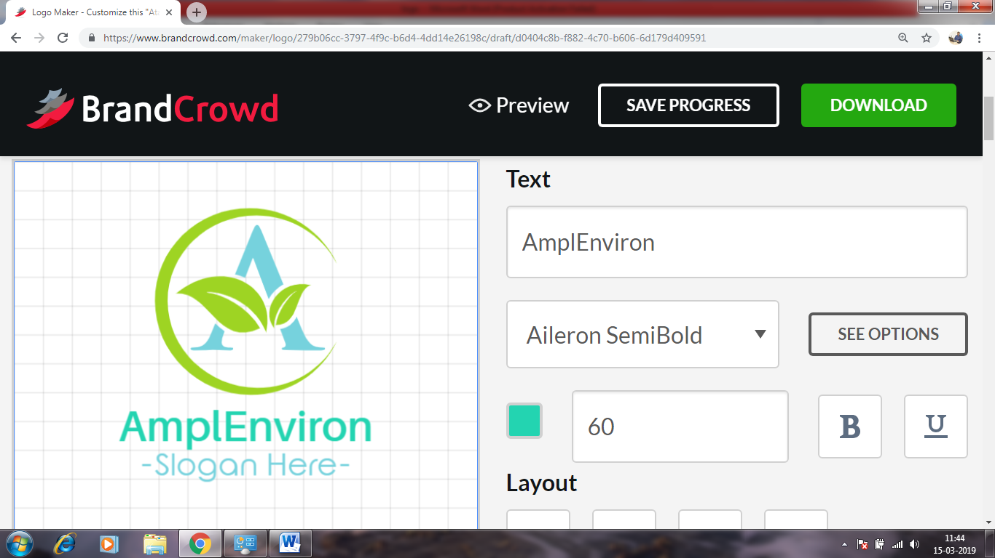

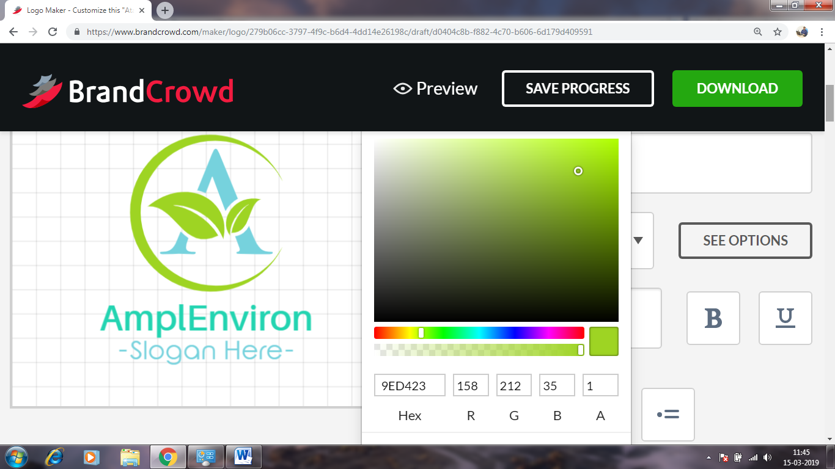

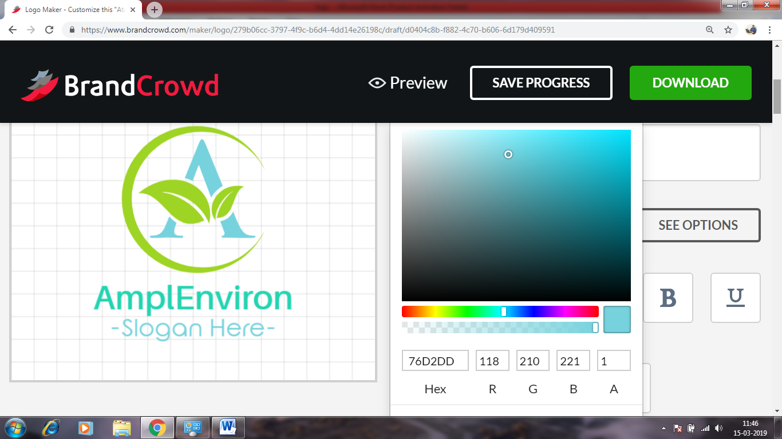



Footer

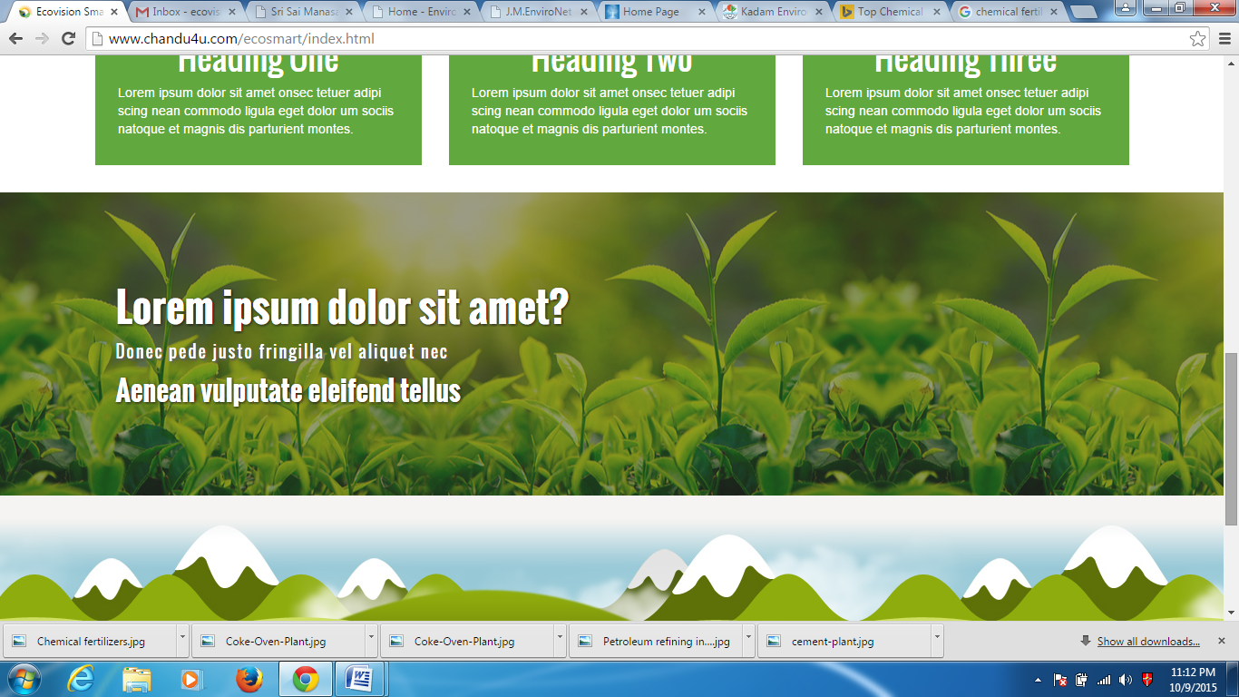

Clients Scrolling

Scroll or random blink of Slogans

Use doc file: Slogans

New & Events – please use New document

Privacy Policy – Use Privacy Policy document

Clients – use client folder for logos

Important Links use - <http://www.greencindia.co.in/services>

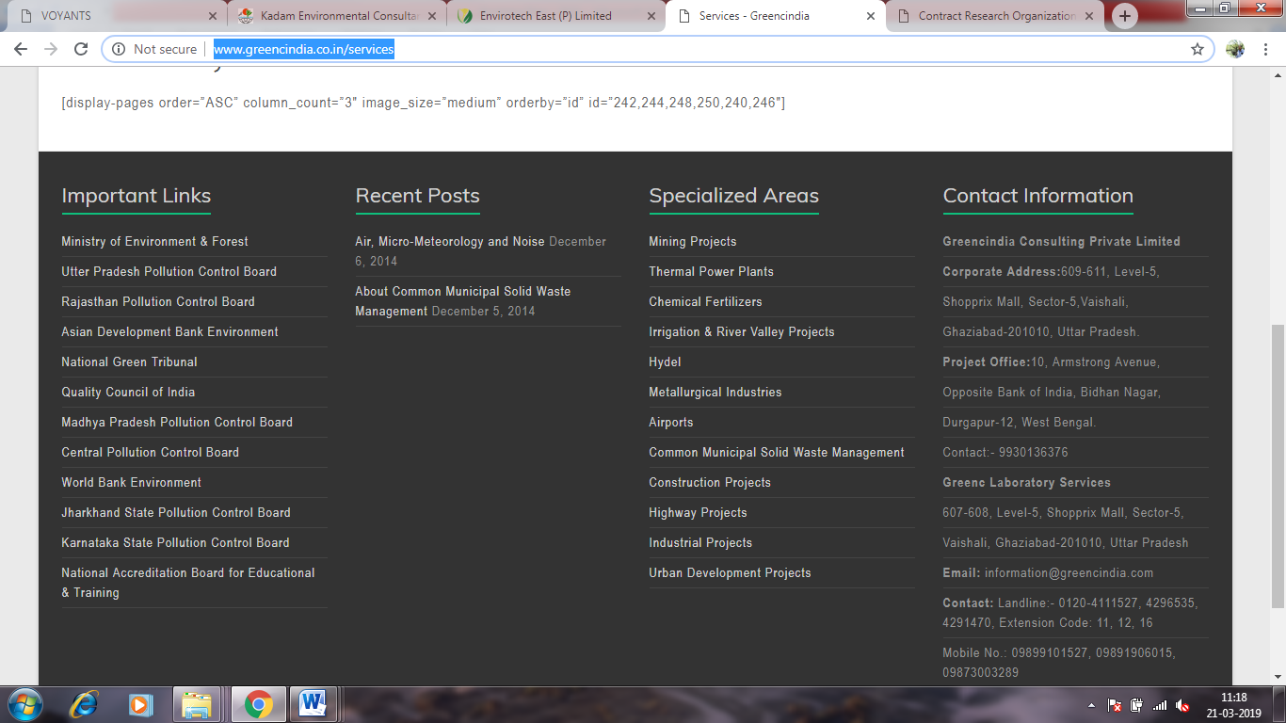

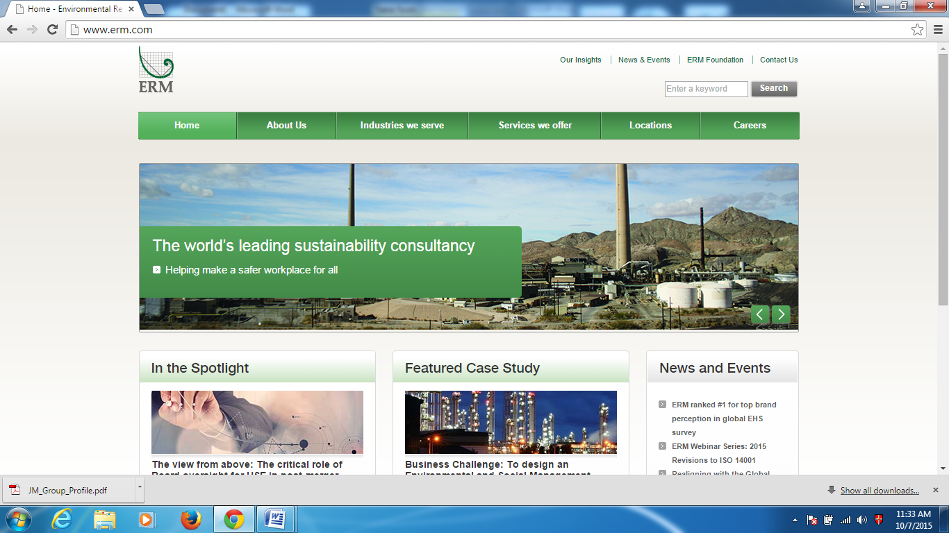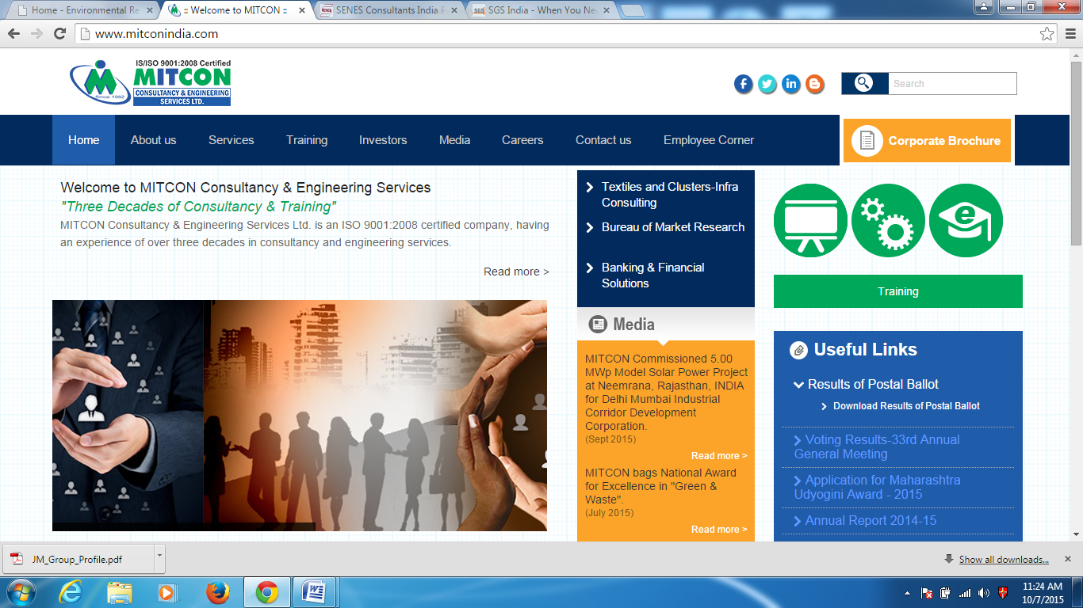

|  |  |  |  |  |  |  |  |
| --- | --- | --- | --- | --- | --- | --- | --- |
| **Home** | **About us** | **Services** | **Sectors** | **Certifications** | **Enquiry** | **Careers** | **Contact** |
|  | **About AmplEnviron** | **Consultancy services** |  |  |  |  |  |
|  | **Mission, Vision & Values** | **Engineering Services** |  |  |  |  |  |
|  | **Quality Policy** | **Legal Services** |  |  |  |  |  |

<https://www.envirotecheast.com/> For Menu Format





Copyright © 2019 AmplEnviro Pvt Ltd. All rights reserved. Privacy Policy | Site Map

Bullets format

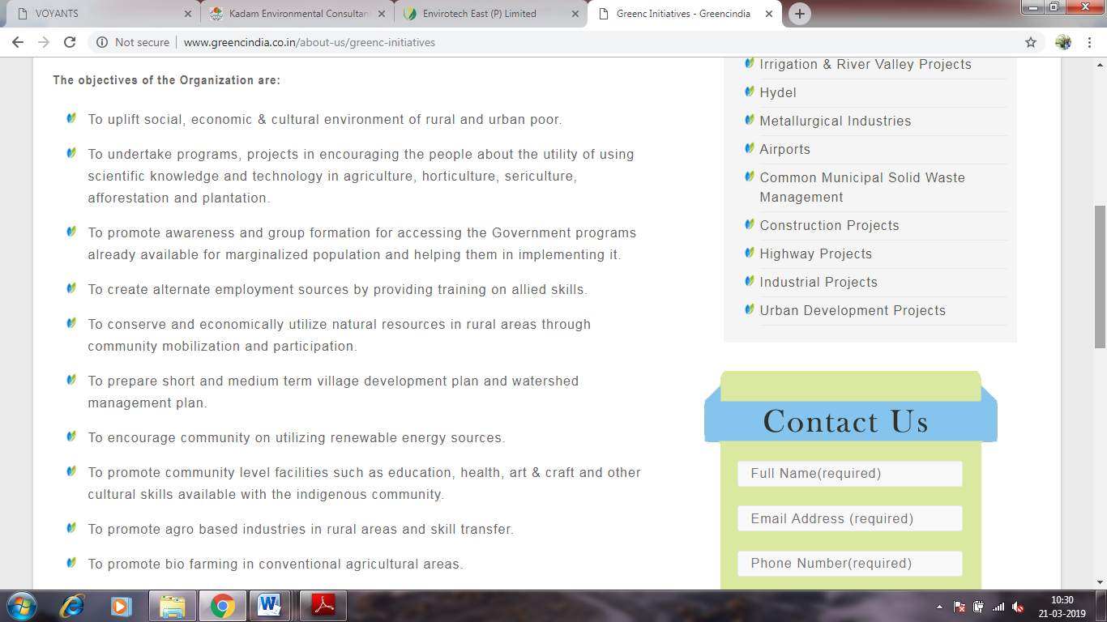

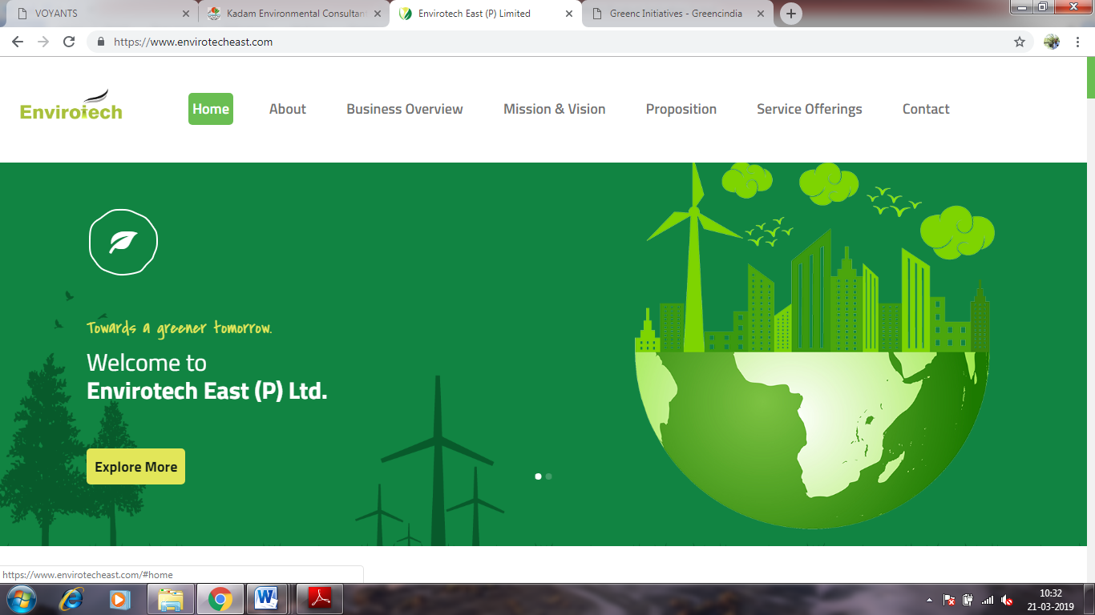Menu Format, Colour, Fonts

Goto Top for all pages

